The Director,

AJAY KUMAR GARG ENGINEERING COLLEGE

GHAZIABAD

__th__________, 2022

**Subject:** Seeking permission for conducting inter college workshop- “Innovacion ‘22“–Focusing on working with microcontrollers and sensors.

Respected Sir,

This is to inform you that SAEINDIA Collegiate Club, AKGEC Innovation Department wishes to organize a inter college workshop “Innovacion-2022” for Delhi-NCR college. The workshop focuses on nurturing young minds to focus on innovation and research. It will teach students to know, how to work with microcontrollers [Arduino] and sensors, which are a basic step towards Internet of Things [IOT]. The workshop, would proceed on live demonstration and hands-on experience for them on the kits provided. We would like to shed light on the fact that the club works to enhance the practical skills and approach of the students. These events will not only help in these goals but also provide an exposure to students about recent innovations taking place around the world. We have planned to organize this “Innovacion ‘22” on 30th April – 1st May [Saturday-Sunday].

Our team has enough experience in the domain of microcontrollers and sensors and their integration over the web.

So, we hereby, request you to **permit** us to conduct this workshop and avail necessary resources in the main seminar hall as well as mini halls. NO accommodation facility is required since student will be of Delhi-NCR College so they can return back to their respective college after each day of the workshop. We shall be highly grateful to you for this.

Kindly grant us permission to work on the preparation for the workshop.

Thanking you

MEMBERS

SAEINDIA Collegiate Club, AKGEC

ATTACHMENTS:

**Annexure A: EVENT OVERVIEW**

**Annexure B: EVENT SCHEDULE AND CONTENT OF THE WORKSHOP**

**Annexure C: KIT DETAILS**

**Annexure D: EXPENDITURE**

**Annexure E: THINGS REQUIRED FROM THE COLLEGE**

**Annexure F: COMMITTEE MEMBERS**

**Annexure G: SEMINAR HALL PERMISSION LETTER**

**ANNEXURE A**

**ABOUT Innovacion’22**

The workshop challenges young minds to learn, compete and provides a platform to be an innovator. The workshop is about making students aware of the possibilities that exist with the micro-controllers (Arduino). We want to encourage the students to think, create and be the change maker.

* The workshop will be organized by **SAEINDIA COLLEGIATE CLUB, AKGEC.**
* The duration of workshop will be of 14- 16 hours and will be covered in 2 days,

[30th April – 1st May, 2022].

* The workshop, would proceed on live **demonstration,** hands**-on-experience** for students on the kits provided. The kits will be take-away kits.
* The Fee of the Workshop will be **Rs ## per participant [In group of five] Or Rs ## per participant as an individual [along with the kit in both cases].**
* At the end of workshop on 2nd day, **Competitions** based on workshop would be organized
  + **Best Innovative Idea**
  + **Best Project Designed**
* The **Competitions** will have a **cash prize** and they will also get a chance to **assist in SAE projects.**
* Every participant will get a **certificate** for the workshop.
* The Registrations will be done **online** from the SAE COLLEGIATE CLUB, AKGEC Website.
* **Components of the Kit**: Node MCU, 2-channel RELAY MODULE, BREADBOARD, 16x2 alphanumeric OLED DISPLAY, 150 RPM DC MOTORS(2 units), 2 WHEEL METAL CHASSIS, ULTRASONIC SENSOR (HC-SR04), IR SENSOR (2 units), L293D IC, Sound Buzzer, DHT11, RFID module, ESP32 camera module, LED (10 units)

**ANNEXURE B**

**Event Schedule**

|  |  |  |
| --- | --- | --- |
| Day | Topic | Duration |
| 1 | Welcome to workshop | - |
| 1 | **Arduino**: Introduction to Hardware and Programming  Arduino: Software Installation | 30 min |
| 1 | 1. LED basics   * **Project 1:** LED Blinking with NodeMCU | 30min |
| 1 | 2. OLED Interfacing  **Project 2:** Text Scrolling | 30 min |
| 1 | 3. DC Motor Interfacing | 30 min |
| 1 | **BREAK** | 30 min |
| 2 | 4. IR Sensor Interfacing | 30 min |
| 1 | **Project 3:** Line Follower Robot with Touch Sensor | 90 min |
| 2 | 5. Ultrasonic Sensor Interfacing  **Project 4:** Water level Measuring Device | 60 min |
| 2 | 6. Humidity Sensor (DHT11) | 30 min |
| 2 | 7. Bluetooth Module Interfacing | 30 min |
| 2 | **BREAK** | 30 min |
| 2 | **Project 5:** Mobile Controlled Robot | 90 min |
| 2 | **Project 6:** Home Automation System | 120 min |
| 2 | **Raspberry Pi**: Introduction to Hardware and Programming. | 30 min |
| 2 | Brief Introduction of **IOT** (Internet of things) | 30 min |
| 2 | **COMPETITION** | 60 min |
| 2 | Closing of Workshop | - |
|  |  |  |

# CONTENT OF THE WORKSHOP

**Day 1:**

**Inauguration of the workshop at 9 a.m.**

* Workshop will start with the introduction of sensors and microcontrollers.
* Introduction to **ARDUINO** and Node MCU Hardware and its Programming (Embedded C).
* When the student will be through with the Arduino hardware and programming, to strengthen their concepts we will start with the interfacing of led and 7 segment displays.
* To implement their knowledge of led and 7 segments interfacing we will make a small project of **Rain Drop Effect** and **Counters.**
* We will then teach them the interfacing of LCD with Arduino, and it will also include a small project **Text Scrolling**.
* After that, we will start with the basics of DC motor and use of motor driving IC L293D and their interfacing with Arduino.

Time for a small break. (In break our Media Team will be interviewing the students for the feedback of the workshop. Few videos out of them will be uploaded on our website.)

After refreshments,

* We will start with the Interfacing of Sensors that includes IR sensor, proximity sensor, LDR sensor, etc. with Arduino and their applications will be discussed.
* Now we will start with our first **major Project** “**Line Following Robot**”, from introducing its application to building it up. It will make them competent enough to participate in various technical fests.
* After completion of the first day of the workshop students must have acquired knowledge that they can build really cool stuff by themselves.

**End of Day 1 at 4 p.m.**

**Day 2:**

* Next day workshop starts at 9 a.m. and it will be another day of zeal for student.
* It will start with the interfacing of ultrasonic sensor with Arduino. To consolidate their knowledge we have kept a minor project of making a device that can **measure** water level in tanks and **petrol level in petrol tanks of a vehicle**.
* After that, we will teach them use of DHT11 Humidity sensor interfacing with Node MCU. In another minor project student will **measure humidity of the surrounding and display it on LCD**.
* Then it’s time for the most interesting interfacing, i.e. interfacing of Node MCU wi-fi Module is use in wireless communication. This interfacing will help student to make devices wireless and operate them remotely.

Time for a small break. (In break our Media Team will be interviewing the students for the feedback of the workshop. Few videos out of them will be uploaded on our website.)

After refreshments

* We will sum up all kind of interfacing and knowledge taught in these two days by our next major project which is **Smartphone controlled remote**. Students will be making it and controlling it with their mobile phones. They can use this RC Robot in different technical events.
* Zeal and enthusiasm will not end here; we will also have our most interesting major project with us. This project is usually a dream project for many students and 4th Year Engineering Project also, "**HOME AUTOMATION**”. How to operate lights and fans of our homes using mobile phones. In this project we will teach them how to operate electrical components using mobile phones.
* Our last session will be based on **IOT**. In order to introduce curiosity of more microcontroller and minicomputer we will give them brief description of ***RASPBERRY PI3b+*** and IOT (Internet of things).
* This is our real aim.
* This is all in teaching session and now it’s time to check how much they have gained and how innovative minds of student are by giving them a competition.
* **Competitions** are:
  + **Best Candidate**
  + **Best Project Designed**
* Student will use their two days knowledge and will try to bring out something innovative.
* Certificates and Prizes (worth Rs1000/-), will be given according to their ideas.
* At last we will give vote of thanks to Director Sir, HOD’s, other professors and college management for given us opportunity to organize this workshop in the college. Workshop will END with the introduction of organizing members who were behind the scene and have worked hard to make this workshop a great success.

**ANNEXURE C**

**KIT ITEM DETAILS**

|  |  |  |  |
| --- | --- | --- | --- |
| **ITEM** | **QUANTITY** | **COST/UNIT** | **TOTAL COST** |
| NODE MCU | 1 | 600 | 600 |
| BREADBOARD | 1 | 100 | 100 |
| LEDs | 10 | 5 | 50 |
| IR SENSOR | 2 | 129 | 258 |
| ULTRASONIC SENSOR | 1 | 200 | 200 |
| DC MOTORS | 2 | 200 | 400 |
| ROBOT CHASSIS+WHEELS | 1 | 200 | 200 |
|  |  |  |  |
| BLUETOOTH MODULE | 1 | 195 | 195 |
| JUMPER WIRES M-M | 15 | 5 | 75 |
| JUMPER WIRES M-F | 15 | 5 | 75 |
| OLED | 1 | 188 | 188 |
| PIR SENSOR | 1 | 90 | 90 |
| Buzzer | 1 | 69 | 69 |
| L293D IC | 1 | 60 | 60 |
| 2 RELAY CIRCUIT BOARD | 1 | 180 | 180 |
| **TOTAL** |  |  | 2740 |

Plus Lunch & Snacks of Rs 200/-

REGISTRATION FEE IS Rs **###** /- PER INDIVIDUAL

TOTAL COST OF KIT= ######/-(KITS WILL BE PROVIDED IN THE GROUP OF FIVE.)

If a student wants to participate individually (with a complete kit) then Registration fee is Rs###/-

## ANNEXURE D

## EXPENDITURE PLAN

* The registration fee is Rs###/- that includes everything.
* Take away kit will be provided in groups of four individuals.
* If a student wants to participate individually (with a kit) then Registration fee is Rs### /-
* Participants are free to choose their group of four members and if they aren’t able to then we will make the group randomly.
* Complimentary snacks will be provided on both the days (2 Samosas with coffee/ tea or Chole samosas with cold drink).
* Study material will be provided in the form of booklet and tutorial videos.
* Booklet will be having theoretical concepts and program codes which will be taught in the workshop for the student’s future reference.
* For expenditure incurred on Flex and Posters for the workshop and ID cards for the organizing team members is requested from the college.

Flex and 8 Posters Cost Rs ####/-

COLLEGE GATE FLEX Rs ###/-

ID Cards Cost Rs ###/-

* The registration process will be online through SAE INDIA COLLEGIATE CLUB, AKGEC Website which is right now under development phase and will become active from 20th January,2022.
* Offline mode of registration will also be there and registration desk will be set up at BB Shed.

# Annexure E

# RESOURCES REQUIRED FROM COLLEGE

The Director,

AJAY KUMAR GARG ENGINEERING COLLEGE

GHAZIABAD

15 April, 2022

**Subject:** Things required from college for conducting a Inter College level workshop- “Innovacion 2022“–Focusing on working with microcontrollers and sensors.

Respected Sir,

This is to inform you that SAEINDIA Collegiate Club, Innovation Department AKGEC wishes to organize a inter college workshop “Innovacion 5.0 – 2022”. The workshop focuses on nurturing young minds to focus on innovation and research. It will teach students to know, how to work with microcontrollers and sensors, which are a basic step towards Internet of Things [IOT]. The workshop, would proceed on live demonstration and hands-on experience for them on the kits provided. We would like to shed light on the fact that the club works to enhance the practical skills and approach of the students. These events will not only help in these goals but also provide an exposure to students about recent innovations taking place around the world. We have planned to organize the workshop on 30th April – 1st May 2022 [Saturday-Sunday].

For this we will be requiring money for following things:

* 3 Flex and 8 Posters Cost Rs ####/-
* 250 Question Papers (Based on which the best candidate will be chosen) Cost Rs ###/-
* 250 Feedback Forms Cost Rs ###/-
* ID Cards Cost Rs ###/-
* COLLEGE GATE FLEX Rs ###/-

So, we hereby, request you to provide financial help in availing above resources. We shall be highly grateful to you for this.

Thanking you

MEMBERS

SAEINDIA Collegiate Club, AKGEC

## ANNEXURE F

## ORGANISING COMMITTEE MEMBERS

# Organising Head

**Head Co-Ordinator’s**

MAHEEP KUMAR, ISHAN SINGH, AKANSHA TYAGI

## Teaching Members

SURYANSH SRIVASTAV, MAHEEP KUMAR, ISHAN SINGH, YASH NARAYAN SRIVASTAVA, NANDINI JAISWAL, AKANSHA TYAGI, LAIBA RAFIQ, VAISHNAVI SINGH, RIYA VERMA, SHIVAM GUPTA, SATYAM TOMAR, PRAVEEN TIWARI, PRIYANKA KUNTAL, SUHEL AHMED, RAGHVENDRA SINGH, UTKARSH SINGH, PRAVEEN KUSHWAHA, MANAS VIR, VIPUL TYAGI, AYUSH GUPTA

## MEDIA, OUTSOURCING and DATABASE

NANDINI JAISWAL , AKANSHA TYAGI , LAIBA RAFIQ , UDAY CHAKRAWAL , PRIYANKA KUNTAL , MAHEEP KUMAR

## Managerial committee

## Resource Committee

## Design and Study Material Committee

## Hospitality

## ANNEXURE G

The Director,

AJAY KUMAR GARG ENGINEERING COLLEGE

GHAZIABAD

15th April, 2022

**Subject:** Seeking permission for using main seminar hall and two mini seminar halls to conduct a College level workshop- “Innovacion’22 “–Focusing on working with microcontrollers and sensors.

Respected Sir,

This is to inform you that SAEINDIA Collegiate Club, Innovation Department AKGEC wishes to organize a workshop “Innovacion”-2022.It will be a two-day workshop on 30th April – 1st May, 2022 i.e. Saturday & Sunday. We have planned to conduct the workshop in the main seminar hall as well as mini seminar halls. Therefore, we need your permission regarding the use of the seminar halls and other peripheral resources required for it.

The workshop focuses on teaching the students the importance of micro-controllers and sensors. Therefore, there is a requirement of a laptop in each team, for that we need extension boards. Following is the list of items we require –

|  |  |
| --- | --- |
| ITEMS REQUIRED | QUANTITY |
| Podium with Mic [For anchoring of the event] | 3 |
| Main projector as well as side projector | 3 each |
| Wireless Mics [for teaching and interaction with the audience] | 12 |
| Whiteboard | 3 |
| Extension Boards | 15 |
| Laser light & PPT remote controller | 1 |
| Crockery (5 Glasses, 5 Cups and Plates, 5 Plates) |  |

Therefore, Sir we request you to provide us the **permission of** main seminar hall as well as two mini seminar halls with above arrangements on the day of the workshop. We shall be highly grateful to you for this.

Thanking you,

INNOVACION ’22 ORGANISING MEMBERS

(SAEINDIA COLLEGIATE CLUB, AKGEC)

**Last Year Photograph on Workshop**

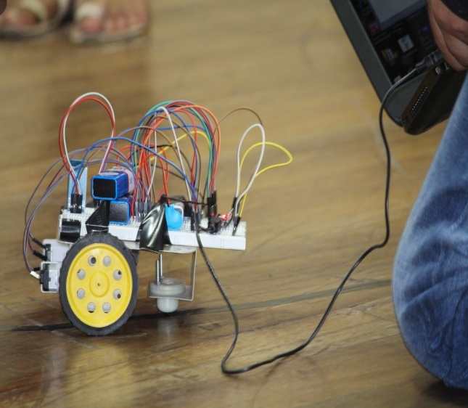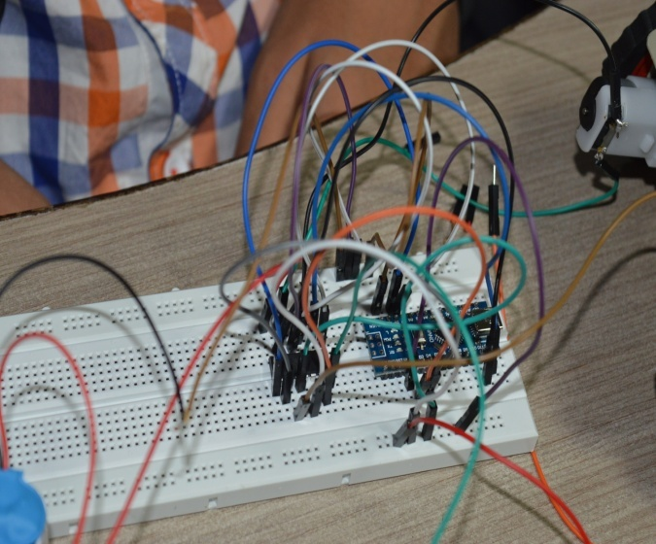

FIG 1- Line Follower Bot FIG 2- Ultrasonic Sensor Interfacing

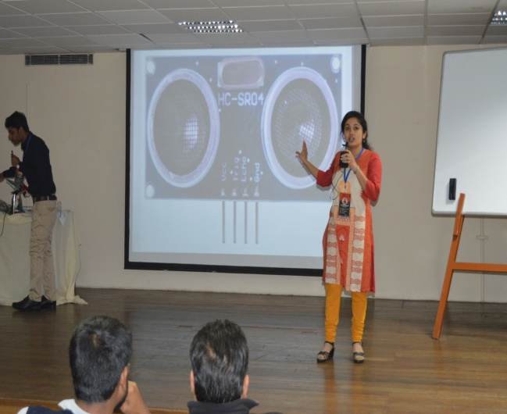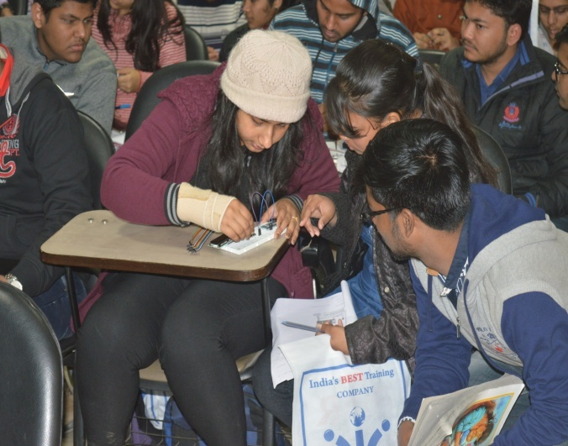

FIG 3- FIG 3-Teaching Member ss FIG 4- Interfacing of LED